**ONE TO MANY  
(one user can create many posts)**

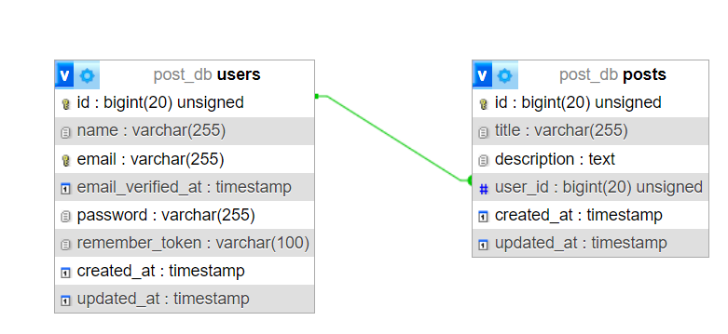

**# PRACTICE 2**

|  |  |
| --- | --- |
| **PROJECT NAME** | **post** |
| **DATABASE NAME** | **post** |
| **TABLE NAME** | **users and posts** |
| **MODEL NAME** | **User and Post** |
| **CONTROLER NAME** | **UserControler and PostController** |

**# users Table Attribute**

|  |  |
| --- | --- |
| **Attribute** | **Data type** |
| **name** | **string** |
| **email** | **string** |
| **password** | **string** |

**# posts Table Attribute**

|  |  |
| --- | --- |
| **Attribute** | **Data type** |
| **title** | **string** |
| **description** | **text** |
| **user_id** | unsignedBigInteger |

**# UserController function**

|  |  |
| --- | --- |
| **Function name** | **Definition** |
| **index** | **Get all users from users table** |
| **store** | **Create new users** |
| **show** | **Get one comment by id** |
| **update** | **Update users by id** |
| **destroy** | **Delete users by id** |

**# API Route**

|  |  |  |
| --- | --- | --- |
| **URI** | **Methods** | **Definition** |
| **/users** | **GET** | **Get all users from users table** |
| **/users/{id}** | **GET** | **Get one user by id** |
| **/users** | **POST** | **Create new users** |
| **/users/{id}** | **DELETE** | **Update users by id** |
| **/users/{id}** | **PUT** | **Delete users by id** |

**# PostController function**

|  |  |
| --- | --- |
| **Function name** | **Definition** |
| **index** | **Get all posts from posts table** |
| **store** | **Create new post** |
| **show** | **Get one post by id** |
| **update** | **Update post by id** |
| **destroy** | **Delete post by id** |

**# API Route**

|  |  |  |
| --- | --- | --- |
| **URI** | **Methods** | **Definition** |
| **/posts** | **GET** | **Get all posts from posts table** |
| **/posts/{id}** | **GET** | **Get one post by id** |
| **/posts** | **POST** | **Create new post** |
| **/posts/{id}** | **DELETE** | **Update post by id** |
| **/posts/{id}** | **PUT** | **Delete post by id** |

**Tip: You need done with CRUD user AND THEN YOU CAN CRUD POSTS.  
For example: Create posts**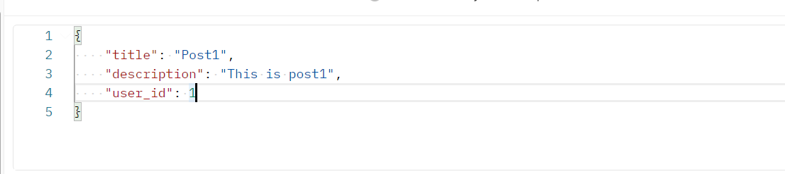

**In table users.**



**In table posts.**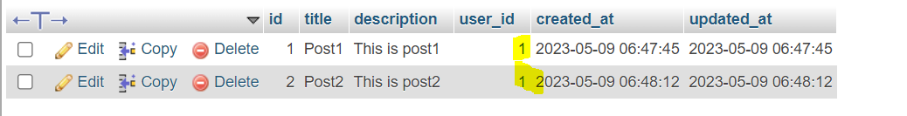

* **I want to know who created whit post id = 1**

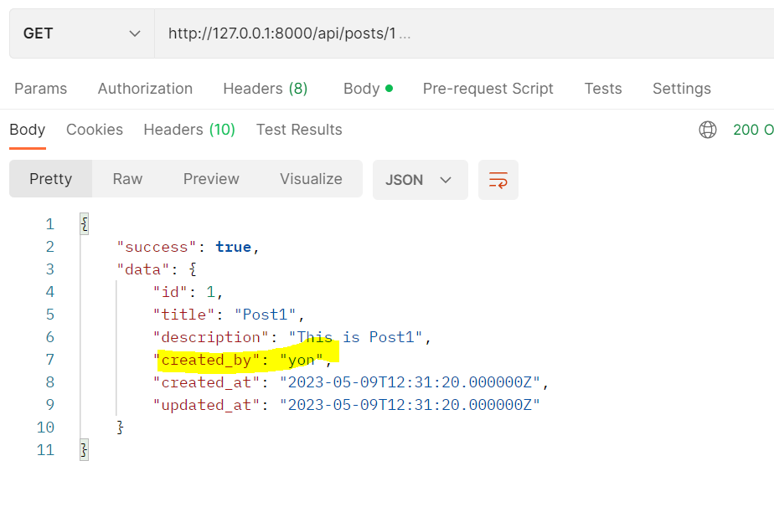

* **I want to know, how many post created by user = 1**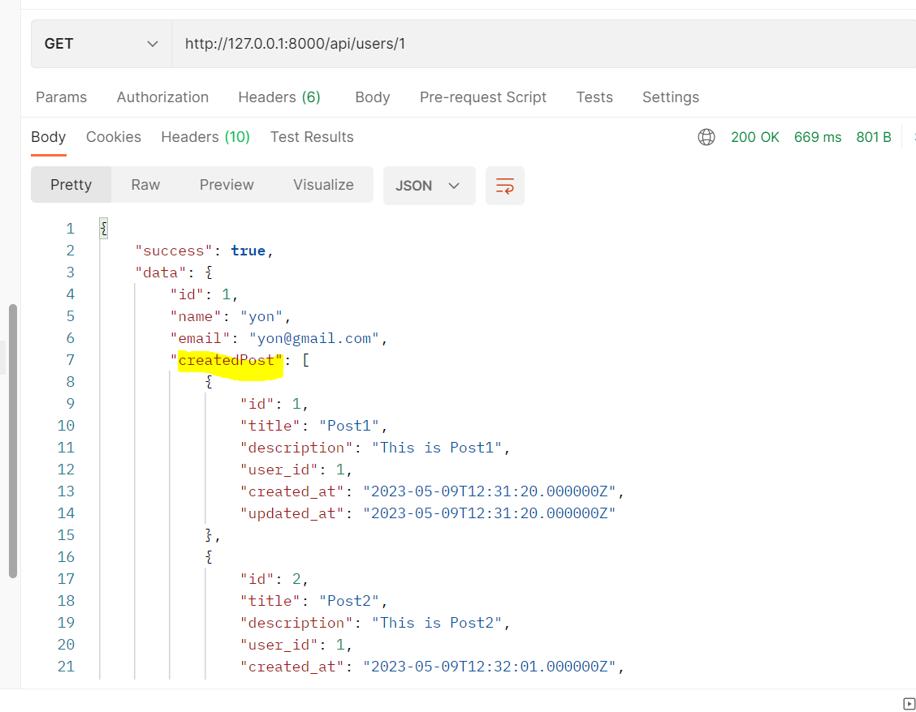

**Note:** <https://laravel.com/docs/10.x/eloquent-relationships#one-to-many>